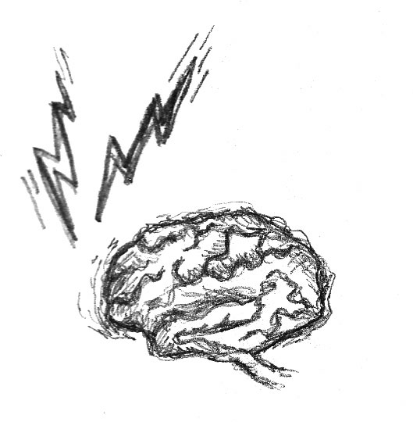

SEO: An Hour a Day

Goals Worksheet

Business Goals
(Fill in the blanks. Use as many or as few spaces as you need.)

Primary Goal
Additional Goal
Additional Goal
Additional Goal
Additional Goal

Website Features
(Check all items below that exist on your website or are future goals for the site.)

This is included on my website now. | This is a goal for the site in the future. | Rating  (Excellent/  Good/Fair/  Poor)
 |  |  | Corporate history, news, and press releases
 |  |  | Executive biographies
 |  |  | Product and service information
 |  |  | Online purchasing/donation
 |  |  | Support for existing customers/clients/students
 |  |  | News and current events
 |  |  | Articles, white papers
 |  |  | Religious, philosophical, or political content
 |  |  | Online request for information (RFI) forms
 |  |  | Login for restricted information
 |  |  | Instructions for making contact offline or via e-mail
 |  |  | Directions, locations, hours, etc. for brick-and-mortar location
 |  |  | Ways for community to connect with each other on the site (forums, etc.)
 |  |  | Educational materials
 |  |  | Links to other resources
 |  |  | Fun, games, or entertainment
 |  |  | A strong brand identity
 |  |  | Art or craft portfolio
 |  |  | Educational materials
 |  |  | Information specifically for geographically local visitors
 |  |  | Software or documents available for download
 |  |  | Media (pictures, audio, video) available for viewing/downloading
 |  |  | Site map
 |  |  | Site search function
 |  |  | Live help/live contact function
 |  |  | Blog postings and reader comments
 |  |  | Customer Testimonials
 |  |  | Methods for your users to help promote your site (email a friend, “Digg this,” etc.)

Connecting Goals!
Use the following space to indicate any disconnects between your business goals and your site’s current functions:

Conversions Table
Fill in the blanks:

Goals  ↓ | Target Audience  ↓ | Conversion  ↓ | Conversion Page (if applicable)  ↓ | Possible Entry Page  ↓

